**<https://www.youtube.com/playlist?list=PLUDwpEzHYYLskkglxoXd0L6DKu4uOfh-m>**

**SDET pavan Rest assured BDD**

[**https://www.youtube.com/watch?v=yDdBOspPp_c&t=3824s**](https://www.youtube.com/watch?v=yDdBOspPp_c&t=3824s)

**API/Webservices Testing using RestAssured Part-1**

**DEPENDENCIES:**

rest-assured

json-schema-validator

json-path

xml-path

testng

java-hamcrest

hamcrest-core

hamcrest-library

apache poi

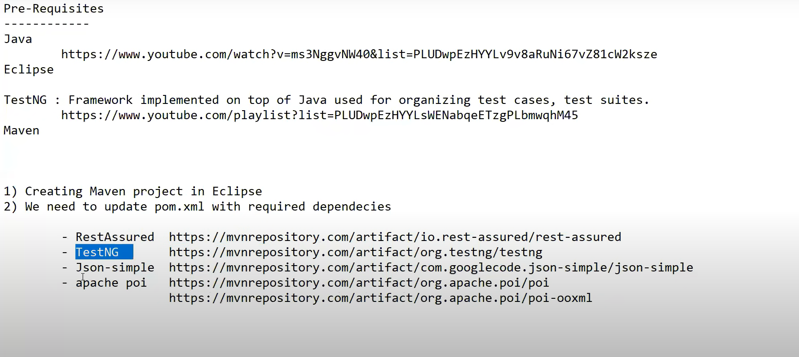

Add dependencies in pom.xml fpr above from mvn respository..

Create Maven Project 🡪 add dependencies in Pom.ml file and (project r.click- Maven – Update project)

Save.

Remove all default packages under src/main/java and src/main/test

Create package under src/main/test as RESTAPITests

* Create class as Demo1_GET_Request
* Create class as RestUtils (random data generator

In General BDD Style is🡪

given()

set cookies, add auth, add param, set headers info etc..

.when()

get,post,put,delete

.then()

validate status code, extract response,extract headers cokkies and response body..

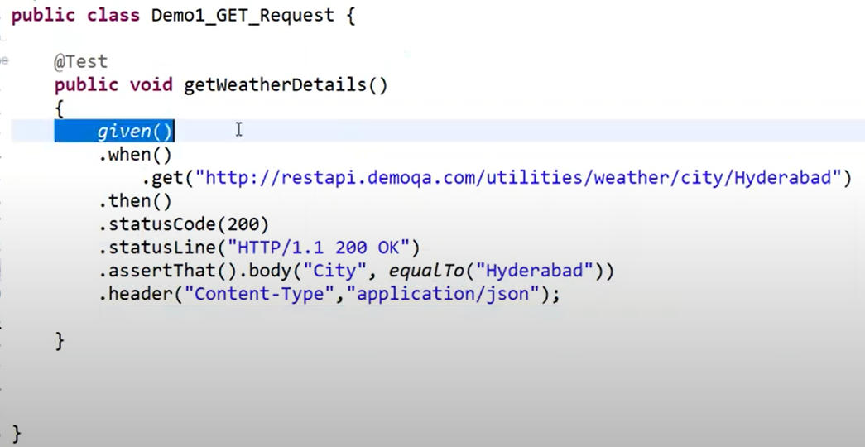

**Now, For POST Request and Response validations & Random Data for POST**:

* Create a class RestUtils (random data)
* Create class for Post Request

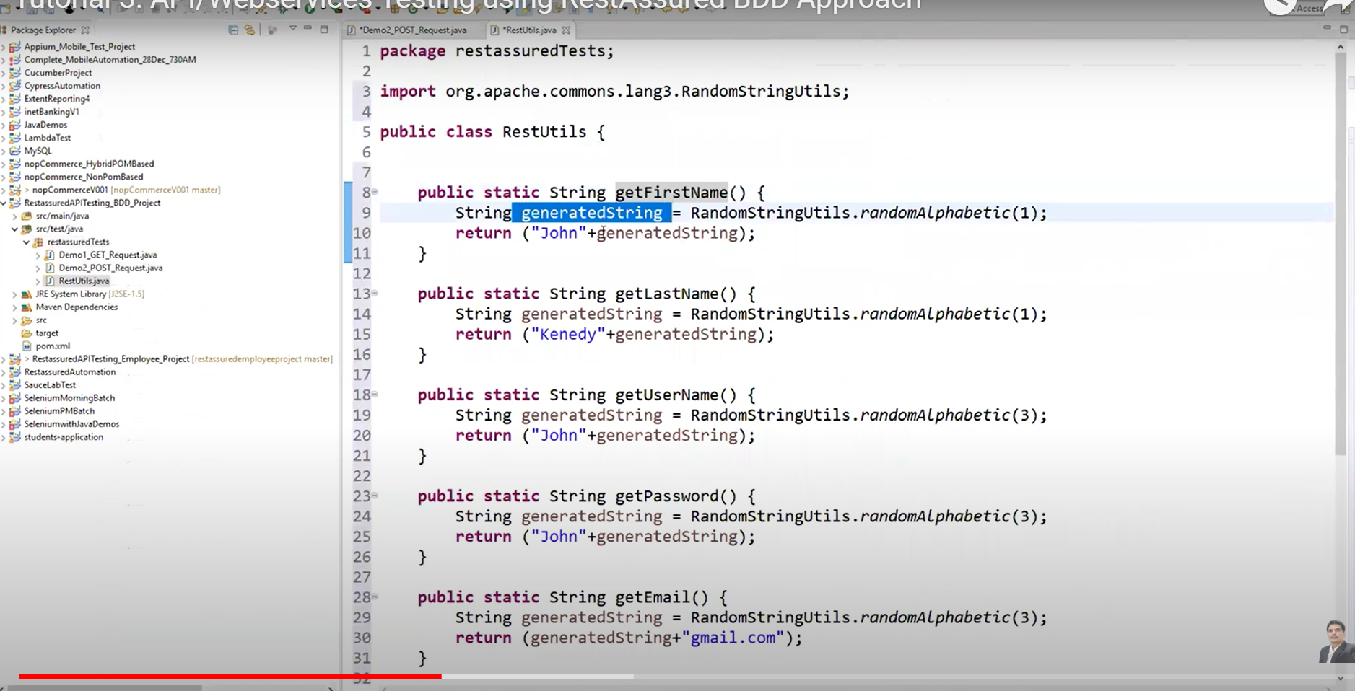

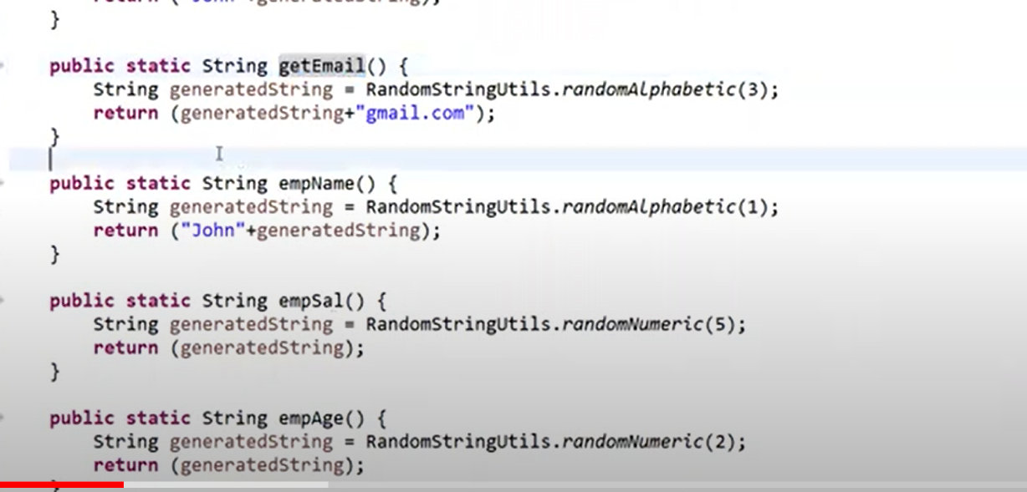

All these are static methods. So, we can call them directly with class name..

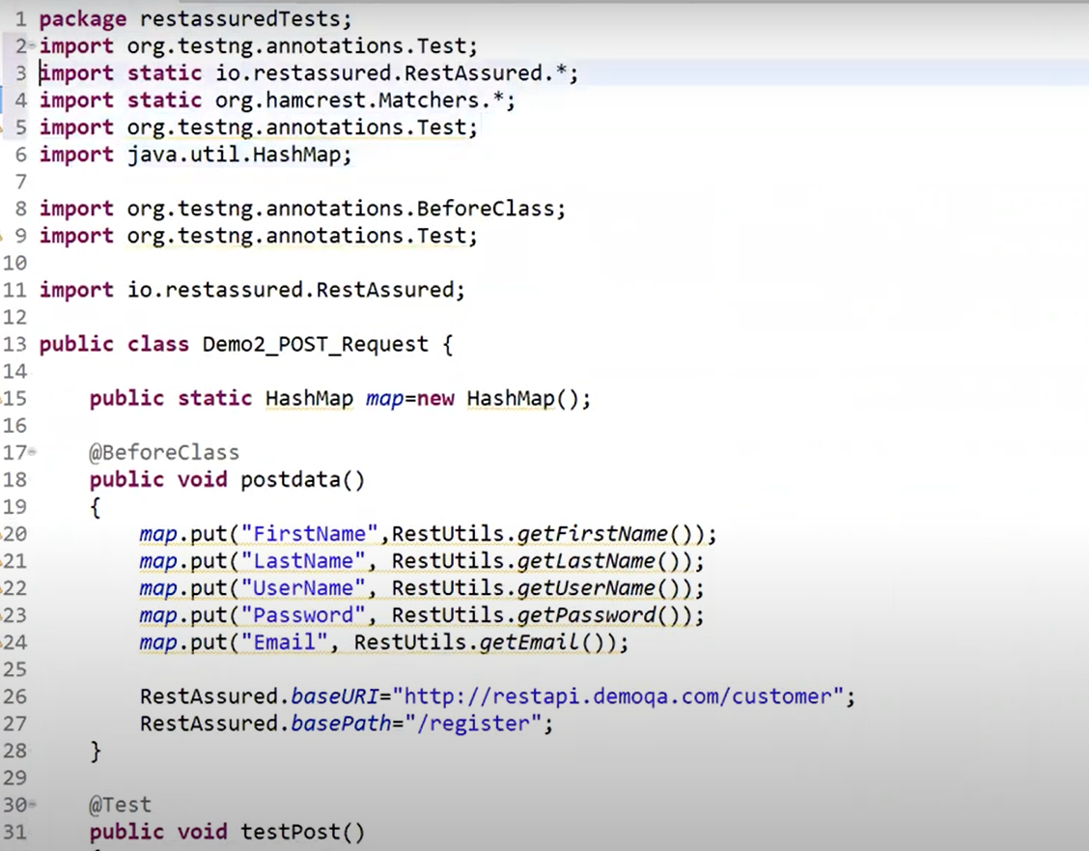

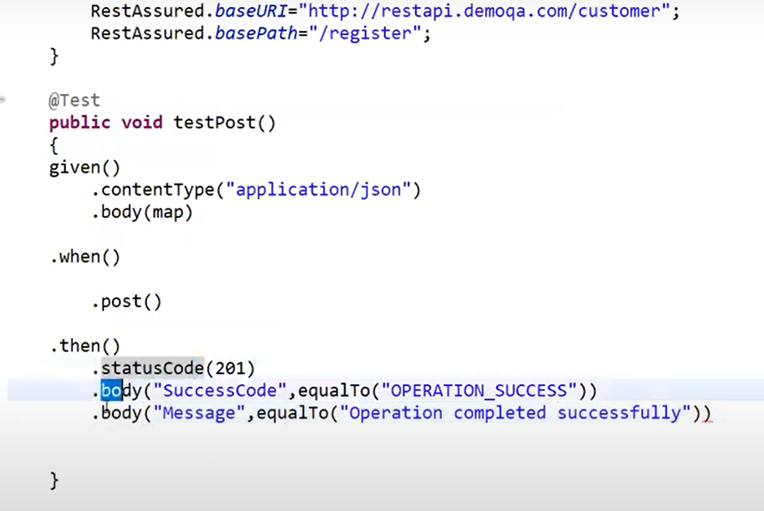

**Send PUT Request:**

**Create class Demo3_PUT_Request**

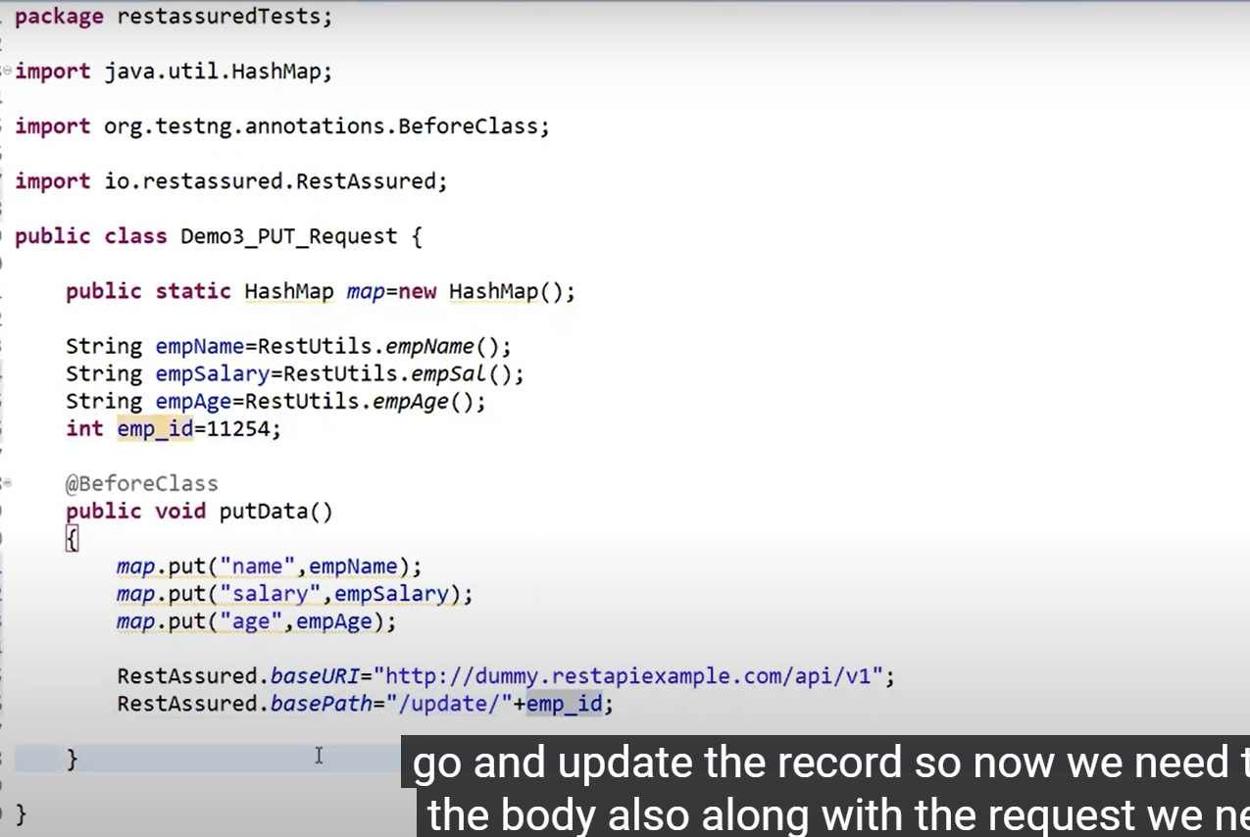

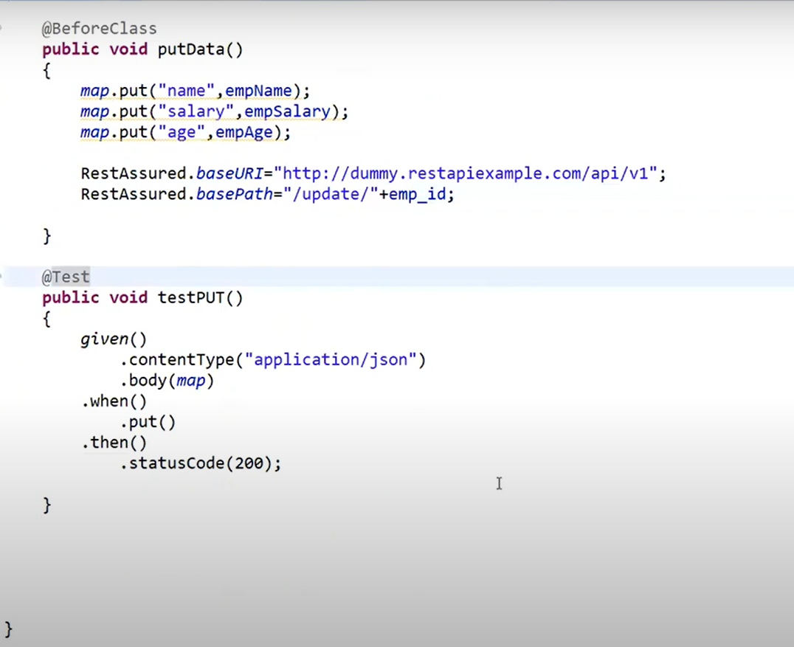

**.log().all();**

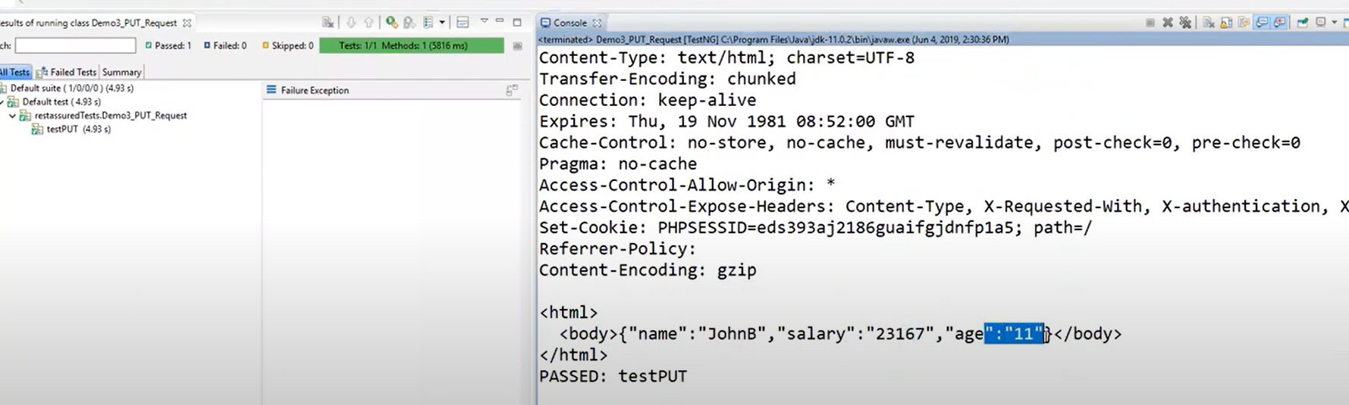

**Send Delete Request:**

**Create class Demo_delete_Request**

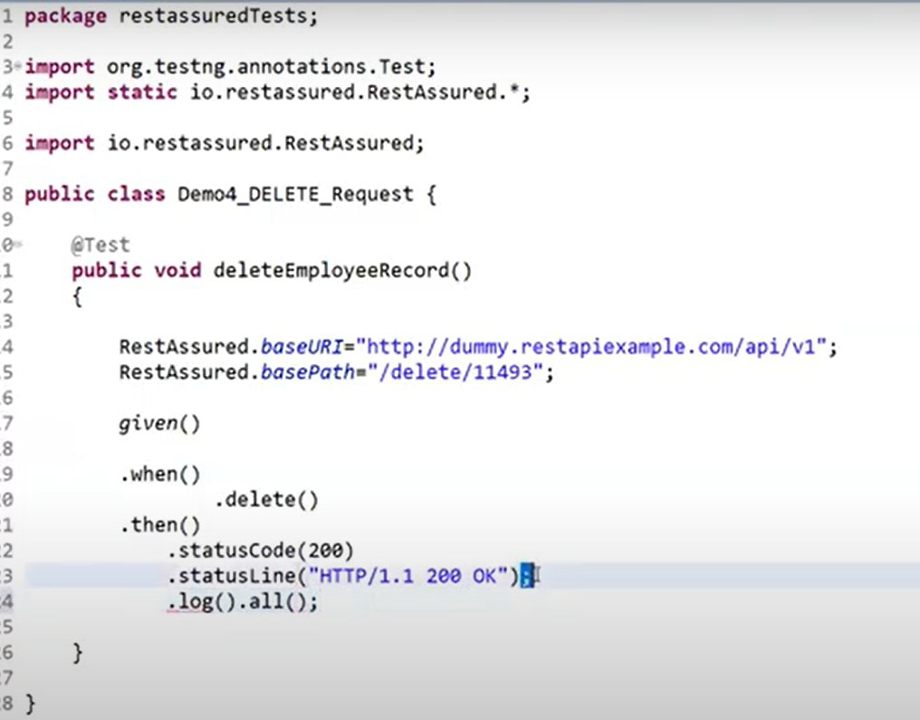

**If we want to capture response body into variable and convert json to string use below code..**

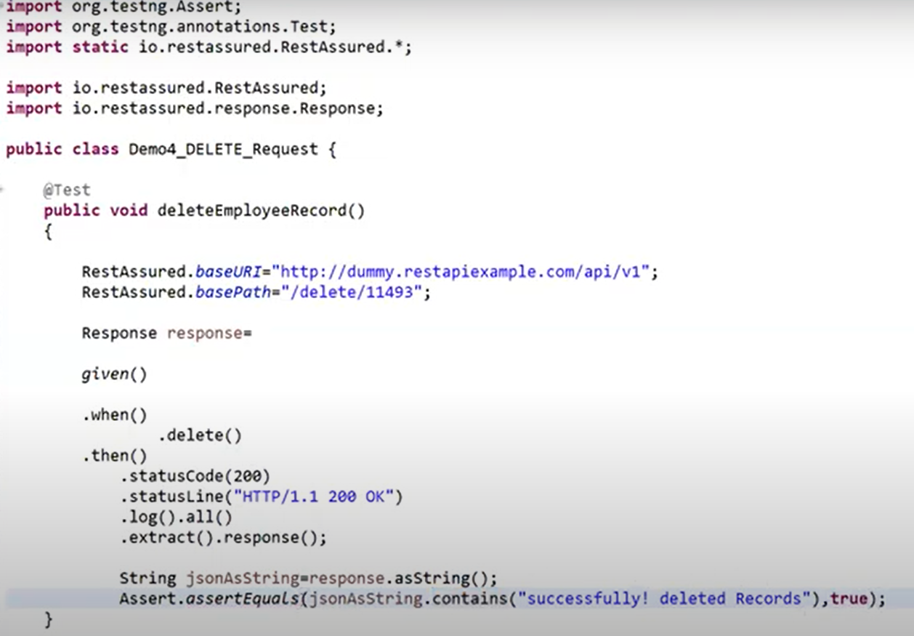

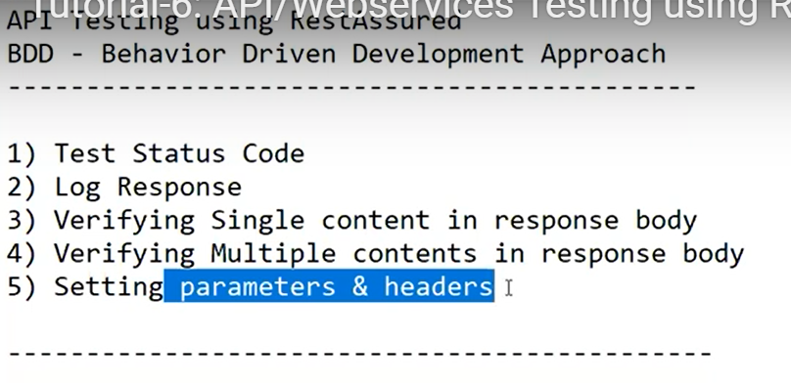

* **Create a class as testbasicvalidations**

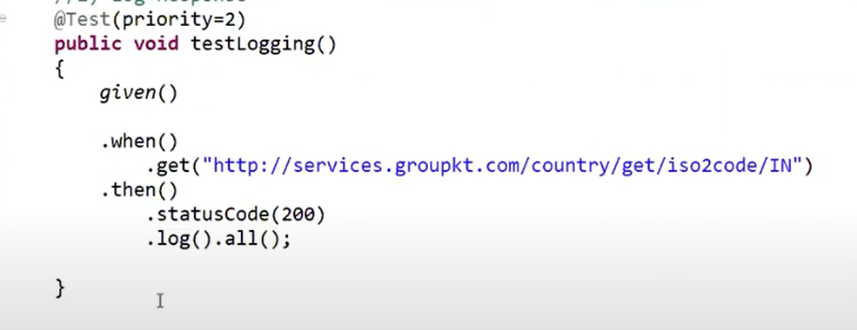

**Validate Response body – We need JSON path, We can use JSONPath Finder browser plugin for Chrome**

* **Copy the response body and paste in jsonpath**
* **Search by name you want path for (name/id etc..)**
* **Copy the path**

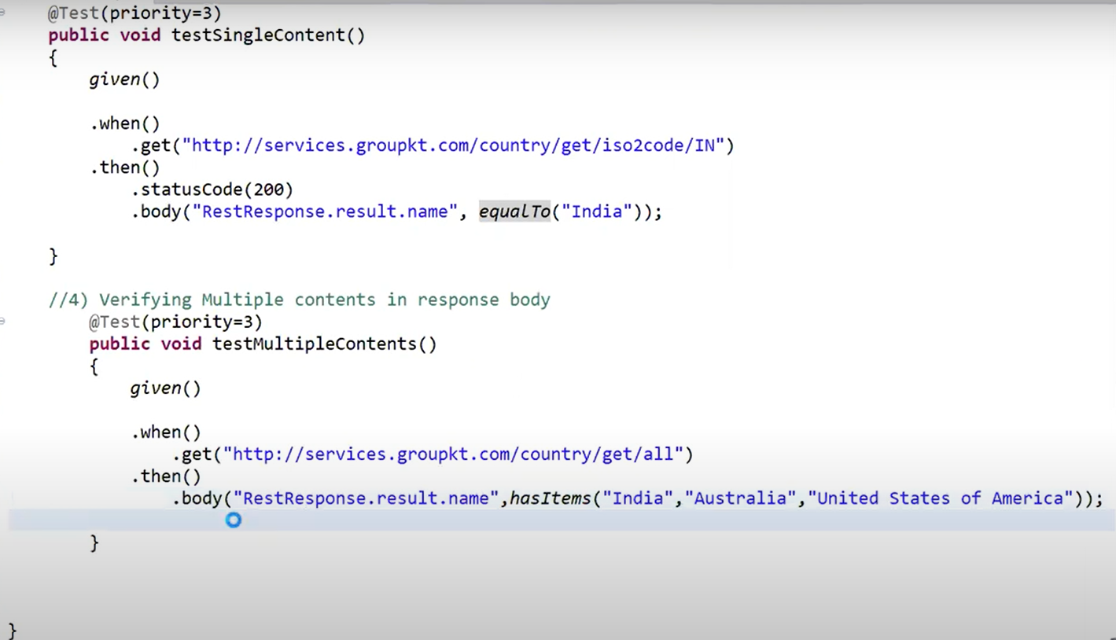

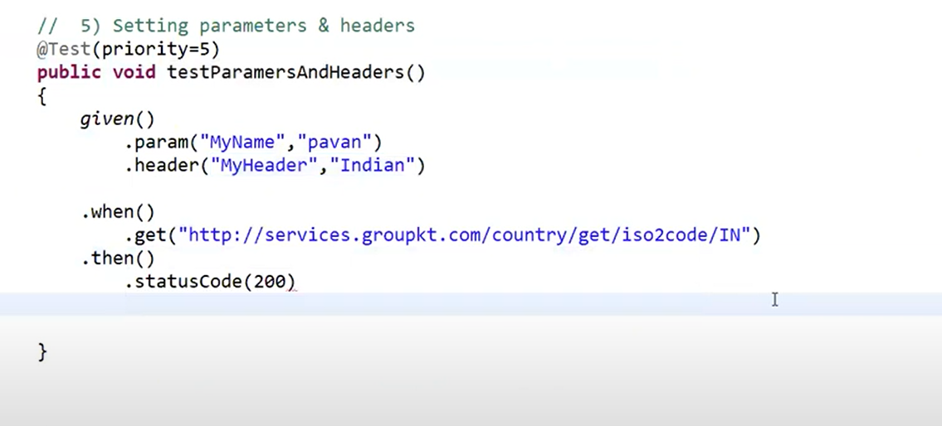

**Serialization and Deserialization in API (usage):**

**Serialization 🡪 is to convert an object into File Format**

**We have 2 classes🡪 FileOutputStream and ObjectOutputStream**

**De Serialization 🡪 Process of converting File into Object**

**2 classess 🡪 FileInputStream and ObjectInputStream**

* **Create package as Serialand desrial**
* **Create a class as Serialanddeserial (use mainmethod)**
* **For class Test need to add implements serializable in order to implement this..(else exception error throws)**

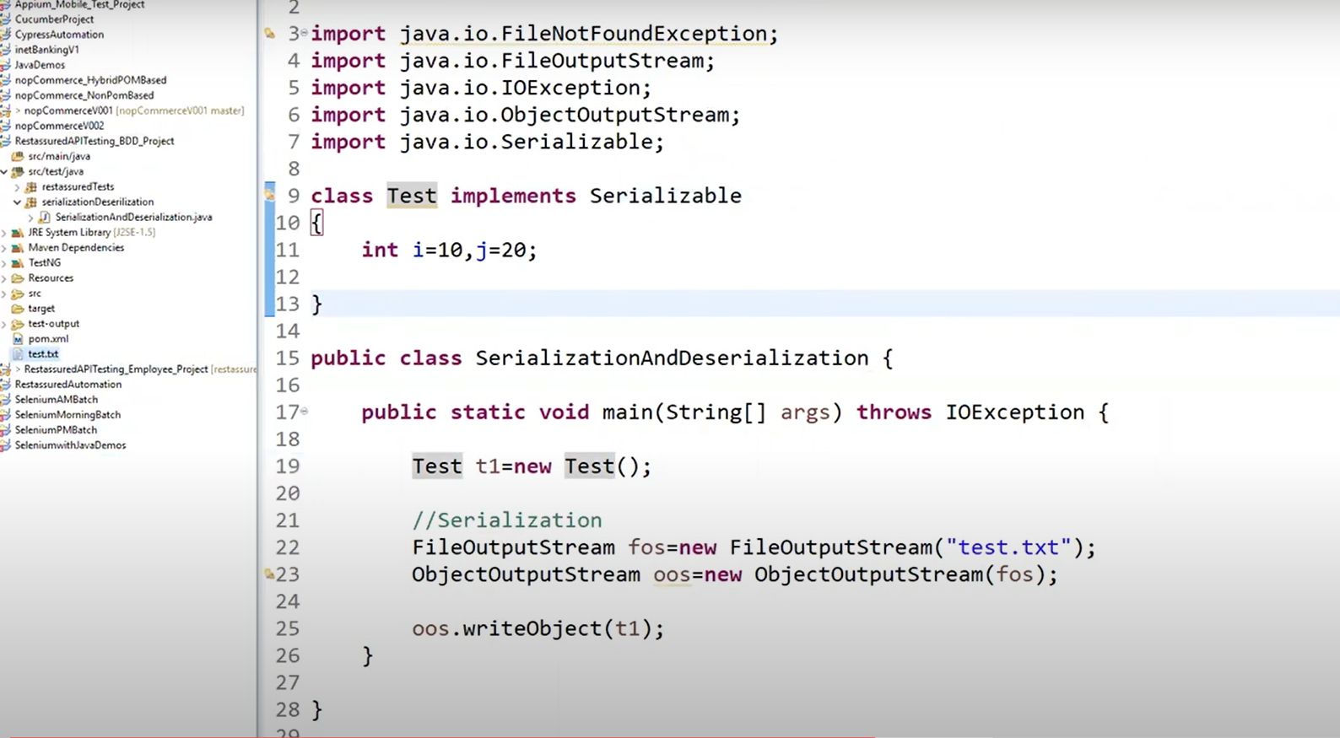

**The test.txt is created under project folder structure, else, we can also specifiy path where we want file created.**

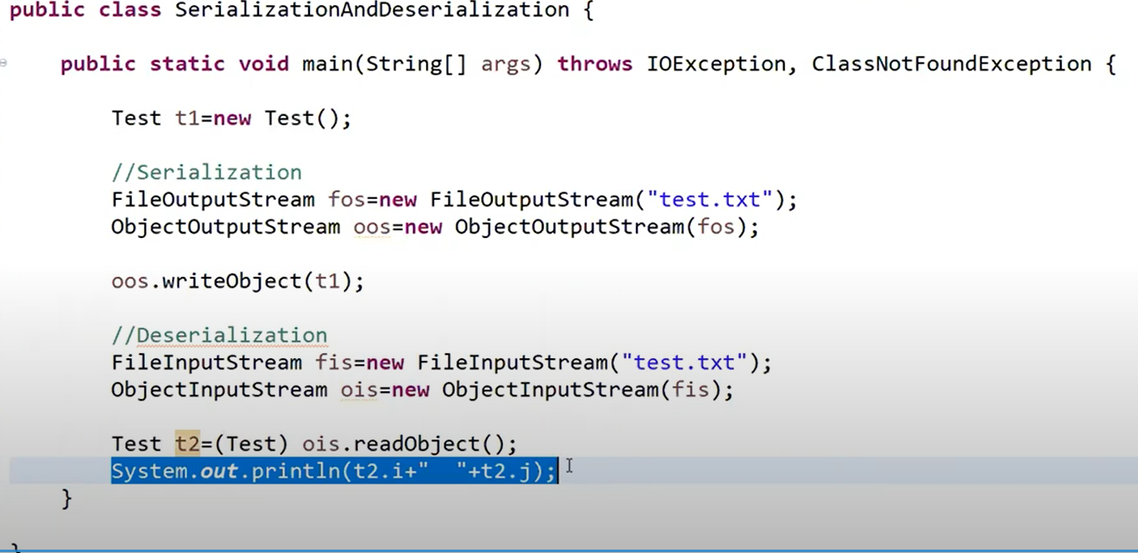

**In API🡪 we normally use this concept for POST request where we use map concept and send json body to create a record. Instead of tht, we can create object and lass for our payload data and convert object into file format,and send file to network**

[**https://www.youtube.com/watch?v=t54-83glFaM&list=PLFGoYjJG_fqo6aAtn-qQn6FWYotoqQ6s5&index=5&t=758s**](https://www.youtube.com/watch?v=t54-83glFaM&list=PLFGoYjJG_fqo6aAtn-qQn6FWYotoqQ6s5&index=5&t=758s)

[Different Tools Setup, Installations & Configuration with One Example](https://www.youtube.com/playlist?list=PLFGoYjJG_fqo6aAtn-qQn6FWYotoqQ6s5)

Naveen labs

**Cucumber Gherkin Feature file creation steps:**

* **Create maven Project**
* **Download eclipse plugin (google and search)**

**Get the link for download and paste in eclipse – market place and paste link**

**Next – Next- finish – restart eclipse**

* **Google cucumber java skeleton, go to pom.xml file**

**Copy all properties from pom.xml and paste in our xml**

**Copy 3 depedencies available – io.cucumber**

**Copy plugins available from pom.xml build section and use ( remove yur existing build section and replace)**

**R.click on project—Maven – Update project.**

**Src/test/java – Create package as app features**

**Create new file as search.feature**

**Src/test/java Create package as stepdefinitions**

**Create class as searchsteps.java**

**Now, yu wil see default feature file created due to plugin we installled,Yu can delete sample fle and write yur own---**

**Feature: notice color changed**

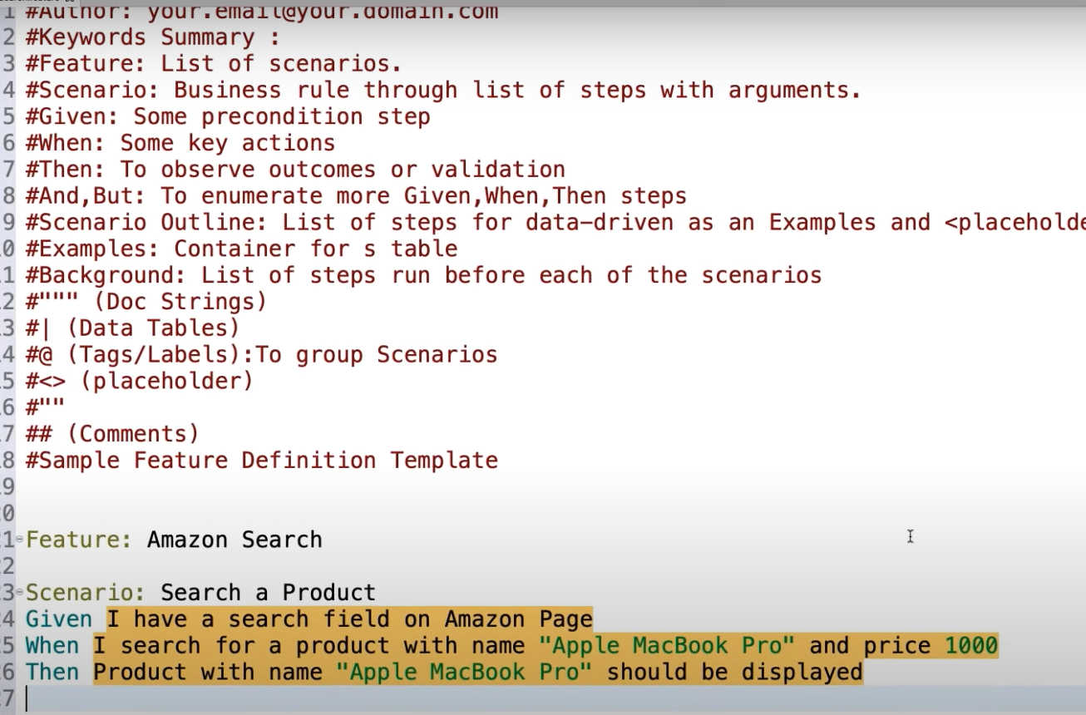

[**https://www.youtube.com/watch?v=BWD8woHxCVM&t=305s**](https://www.youtube.com/watch?v=BWD8woHxCVM&t=305s)

# API/Webservices Testing using RestAssured Part-5 | Rest Assured Framework

**Execute Tests from Eclipse different ways:**

1. **Testing.xml**

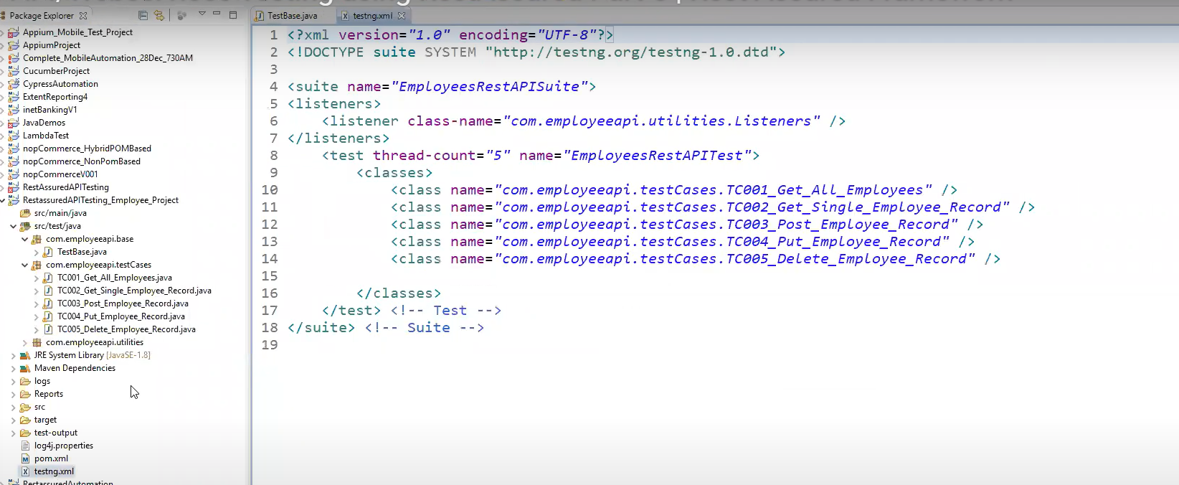

**Run as testNg Suite..**

1. **POM.xml**

**We have 2 plugins maven-compiler-plugin and maven-surefire-plugin**

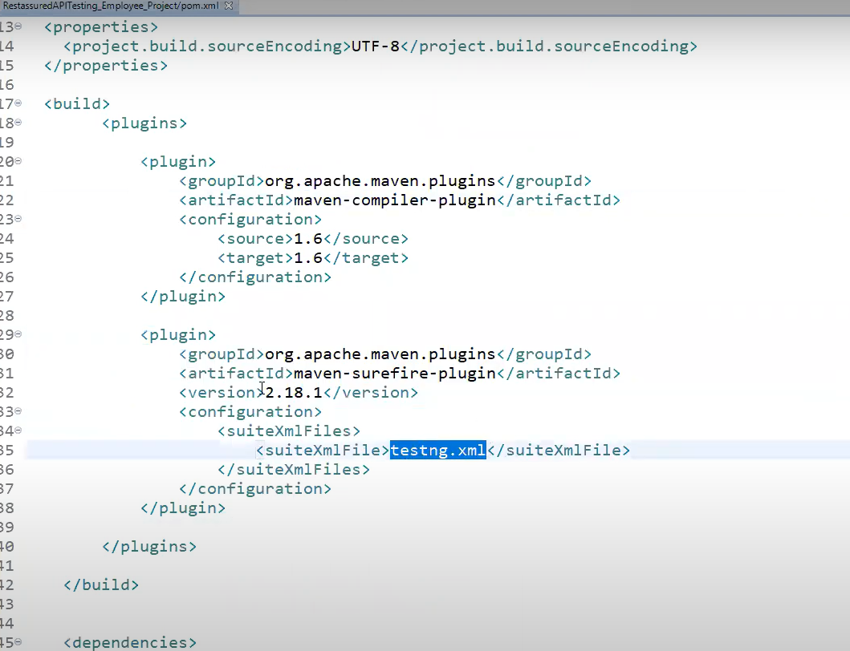

**Compiler – will compile your project**

**Surefire – will execute your project ( we have specified testing.xml file to execute)**

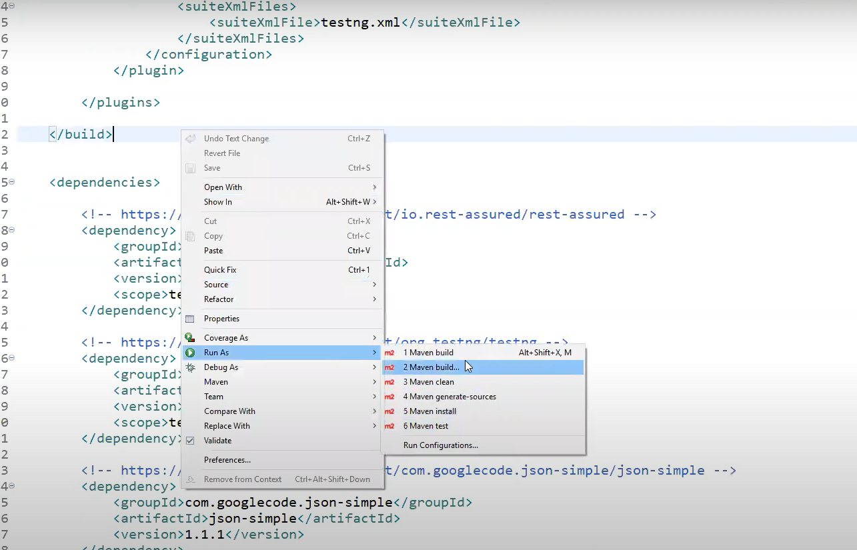

**Run as Maven test..**

1. **Command Prompt**

* **R.click o project get project location path from resources**
* **Copy and paste in local drive (path)**
* **Click on cmd**
* **Install Maven on windows OS system, google apache maven for windows**

**Download binary zip archive (jars) and Extract the zip file in C or D drive.**

* **Go to bin directory and copy path upto bin**

**Navigate to environment variables and go to path under system variables**

**Edit – new- paste the path**

**Go to cmd and type mvn -version (u should see maven installed)**

**To Execute, go to cmd and navigate to path where project is:**

**Run as mvn clean install (ignore warnings)**

* **All tests will be executed and all logs show on cmd prompt**
* 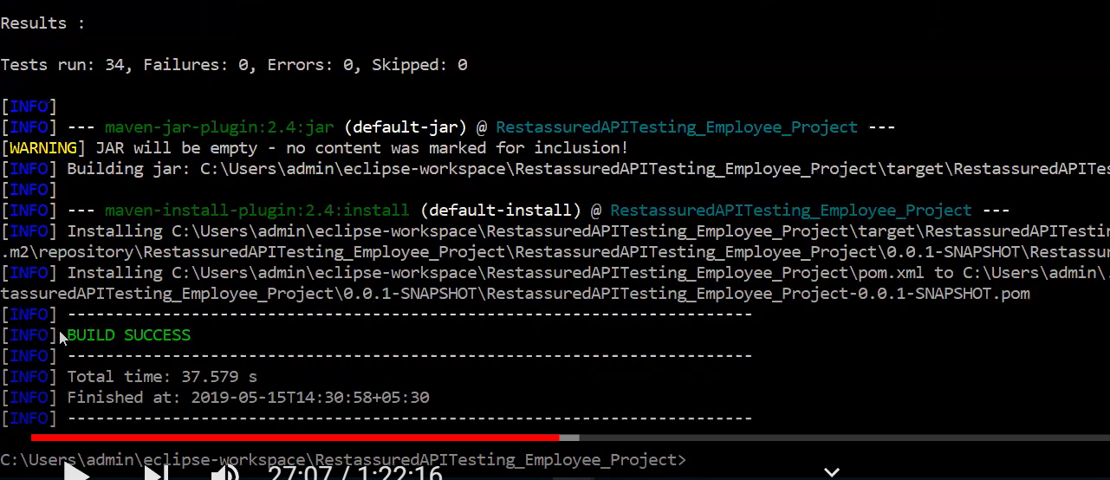

1. **Execute tests using run.bat file**



**Go to project path in C Drive and r.click add new text file, name as run2.bat**

**r.click on file and click edit – add above commands.**

**Double Click on bat file to execute commands.. (opens cmd prompt and executes commands)**

**To see logs for errors – go to logs folder – log file is generated**

**JENKINS-🡪**

**Down load Jenkins from google—**

**Shows all options winows-mac -rehhat – etc… also shows generic java package.war file**

**This wasr file is generic used for testing training..others are exe files..**

**I think exe will be used by clients..not generic…**

**C:Drive / create jenkis folder/pate the war file we downloaded**

**Cmd from path**

**java -jar jenkins.war**

**takes some time- uwillsee mesge as Jenkins up and running (minimize window do not close)**

**open chrome localhost:8080**

**Create item- New Item – name as test_proj- select free style -ok -directly go to build section-**

**Execute windows batch command ( as we are running run.bat command from above)**

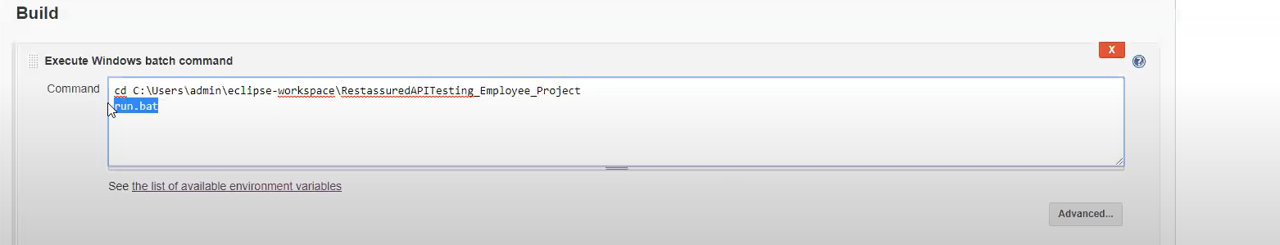

**Apply and save.**

**Selct your project from dashboard – Test_proj – click build now-**

**Click on progress bar – shows log view tests running..**

**Will see build success in log if all passed..**